MENSTRUAL HYGIENE SYMPOSIUM
Theme: #APadAGirl
Sponsored by: P & G in Collaboration with
Kids & Teens Resource Centre
Kola Ogunmola Street, Ijapo Estate, Akure. 08035606915, @KidsAndTeensNG
Date: 19th July, 2017
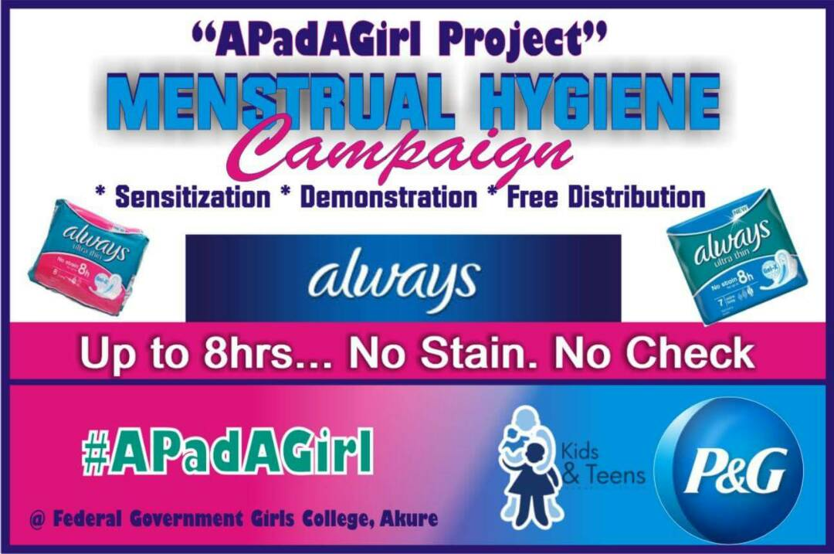

TABLE OF CONTENTS
Cover page………………………………………………………………………………………………………………...1
Table of contents……………………………………………………………………………………….………........2
Abbreviations and acronyms……………………………………………………………………………………..3
Executive Summary………………………………………………………………………………......................4
Goals and Objectives…………………………………………………………………………….......................5
Opening……………………………………………………………………………………………………………………..6
Activities that took place …………………………………………………………………..……………….6-11
Observations…………………………………………………………………………………………………………..11
Recommendations…………………………………………………………………………….......................11
Conclusion………………………………………………………………………………………………………………11
Annex……………………………………………………………………………………………………………………..13

ABBREVIATIONS AND ACRONYMS
K&TRC: Kids & Teens Resource Centre
MHM: Menstrual Hygiene Management
P & G: Procter & Gamble

EXECUTIVE SUMMARY:
The silence around Menstruation as well as the lack of access to sanitation facilities and hygienic absorbents in developing countries affects women and adolescent girls’ self esteem, health and education. There are cultural practices and myths regarding menstruation that makes it a taboo. This has made menstruation to remain a private matter which makes women and girls suffer in silence. Young girls especially, tend to get information about Menstruation from peers who are not adequately informed about menstruation, thereby giving out perverted or half baked information. This has led to some irreparable damages among some Adolescent.
In a bid to address these issues, K&TRC organized a symposium at Federal Government Girls’ College, Akure with support from P&G. The program created an avenue for awareness on menstrual hygiene and its related issues. The topics treated include; menstruation, challenges faced by girls and women, addressing the challenges, understanding the menstrual cycle, menstrual hygiene management among others. The students were given opportunity to ask questions on menstruation and their sexual and reproductive health. There was a demonstration on how to properly use and dispose Always Sanitary Pads.
Always Sanitary pads were distributed to the students. There were 500 female students, 5 Teachers and 7 Staff/Volunteers of K&TRC in attendance.

GOALS AND OBJECTIVES:
Goal
To increase the uptake of Always Sanitary Pads and knowledge of menstrual hygiene among students in Federal Government Girls College, Akure
Objectives
- To improve knowledge of menstrual hygiene among students in Federal Government Girls College, Akure
- To enhance the use of always sanitary pads among students in Federal Government Girls College, Akure

OPENING
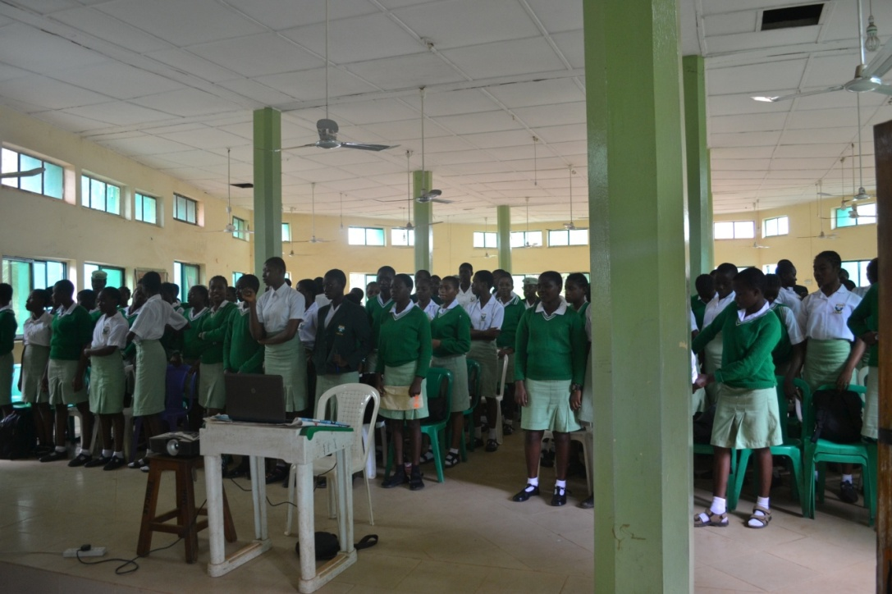
The program started 10:45a.m with the second stanza of the National Anthem as an opening prayer. A welcome address was given on behalf of the Executive Director K&TRC, Martin-Mary Falana. He enjoined the students to be attentive in order to benefit from the lectures. The Vice Principal Special Duties, Mrs Okunade gave a welcome address on behalf of the school’s management. She appreciated the organizers of the program for coming up with a talk on menstrual hygiene and also P&G for the Always Sanitary Pads to be distributed.

ACTIVITIES
- A talk on Menstrual Hygiene
The Program officer of K&TRC, Ajibola Oluwakemi gave an educative lecture on Menstrual Hygiene in which the students were taught about menstrual cycle, common symptoms associated with menstruation which includes menstrual cramps, bloating, acne breakout, abdominal pain, nausea etc. she highlighted some of the challenges faced by girls and women; lack of quality sanitary protection materials leading to embarrassment and stress due to leakage and smell; lack of menstrual hygiene-friendly facilities, inability to change materials and clean up due to lack of WASH ( water, sanitation and hygiene) facilities, presence of dirty toilets etc, leading to absence from school or work, exclusion from WASH facilities; in some communities women and girls are not allowed to use water sources during menstruation, fear of using the toilets due to fear of staining it, lack of privacy, unsafe location of toilets, etc.
She cited some stories from girls in other countries to show that these were universal issues:
“I didn’t know what was happening or what to do to manage menstruation. I used cotton wool, pages from an exercise book, leaves from trees. I suffered much embarrassment at school because I leaked and stained my uniform.” Girl, Tanzania
“Guidance and support at school is more important than anything. There is nobody to talk to. When we have problems we just run from class and go home.” Student, Malawi
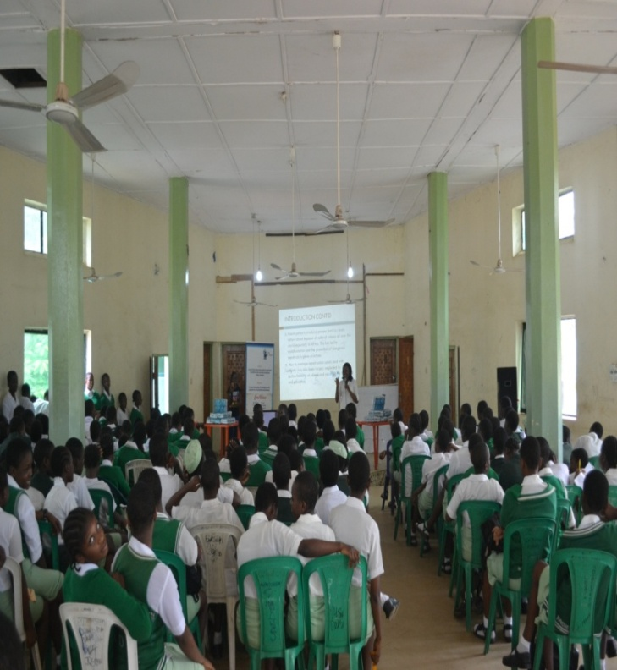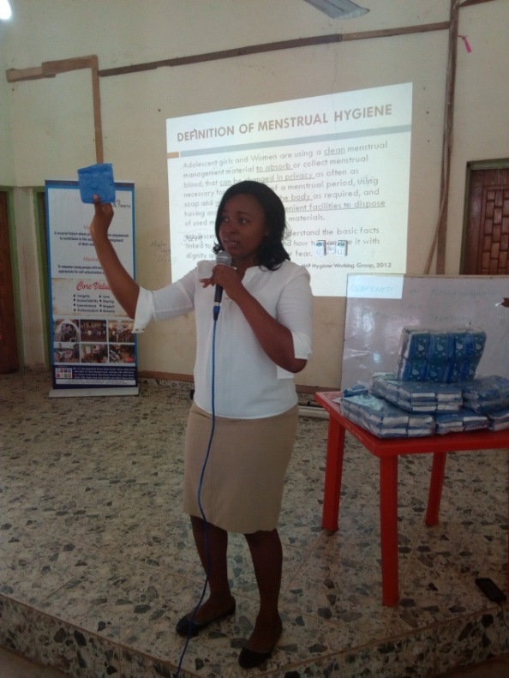
The program officer giving a lecture on Menstrual Hygiene

- Demonstration on proper usage and disposable of pads
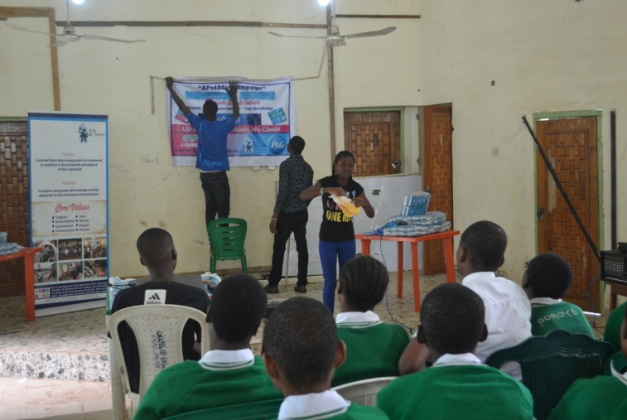
Kemi, the Admin Officer of K&TRC gave a brief demonstration on how to use the sanitary pads. She also mentioned the proper disposal methods which includes; burning, burying, and wrapping properly in a nylon bag before disposal in the waste bin.

- Questions and answers session
Questions were asked based on menstrual health and myths surrounding menstruation. A student asked why menstrual pain? The program officer responded that it is due to physiological differences; some people experience pains while others don’t, the pains reduce in some after childbirth. Another student asked who was the first point of contact at the onset of menstruation? The responses came from different participants and it was concluded that anyone that you are comfortable with. There were questions that cuts across all the topics discussed and they were all answered correctly.
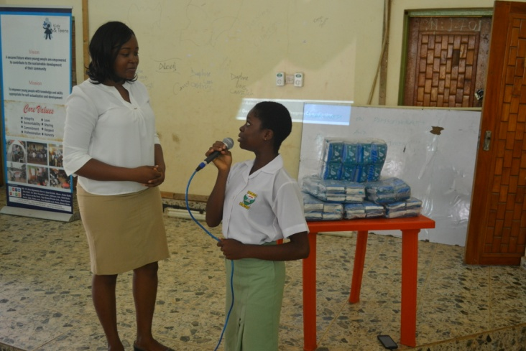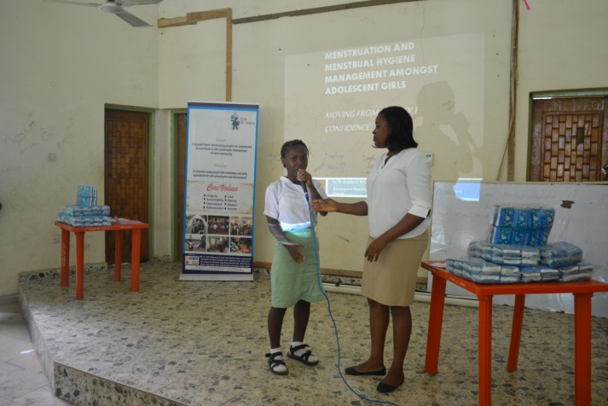
Students asking questions about menstruation and myths

4.0 Closing remark
The closing remark was given by a student representative of Federal Government College Akure. She appreciated the organization for choosing their school for the program and also giving a talk on menstrual hygiene. She said most times the students are shy to ask questions relating to menstruation because it is seen as a private matter. But after the talk, they were given platforms to ask questions and they were answered. She thanked P&G, the distributors of Always Sanitary Pads for making the sanitary pads available to the students. In her own words “Always Sanitary Pads is the best and most of my friends use it during menstruation. It is comfortable and there are no leakages. I really appreciate Always Nigeria for giving us their products for free”.
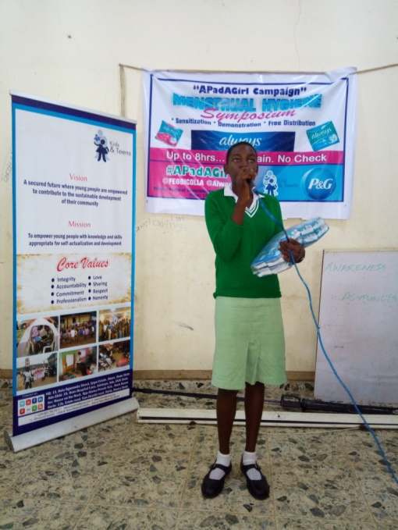

5.0 Closing prayer:
The second stanza of the National Anthem was adopted as the closing prayer. Group Picture was taken afterwards.

OBSERVATIONS
- The students were attentive and ready to learn.
- The students participated by asking questions making the program an interactive one
- The students had a lot of questions revealing a huge gap as regards Menstrual Health and Hygiene education.

RECOMMENDATIONS
- A representative of P&G can be assigned to attend programs such as these so the community can be brought closer to P&G and how it works
- There should be establishment of Girls only Health &Hygiene Club in schools where girls can be mentored on menstrual hygiene and are free to speak out on issues bothering them.
- P&G can provide more opportunities for distribution to help girls attain their full potentials.

CONCLUSION
Sanitary Pads empower women, keep girls healthy and in School. Through the #APadAgirl project we were able to raise awareness about the importance of menstrual health and hygiene education and ensure that the sanitary pads were available.
This project has set in motion the process for addressing the menstrual management needs of the target group which we hope to scale up and sustain.
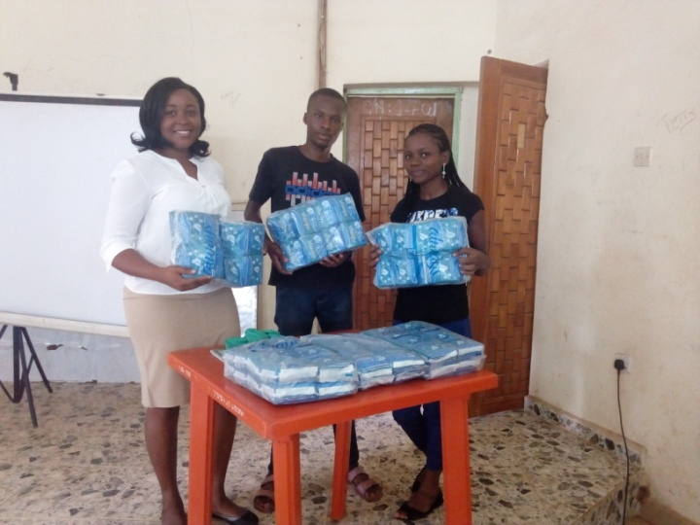

ANNEXE
PICTURE GALLERY
