Autism Spectrum Disorder
Celebrating a Social Worker with a Difference!

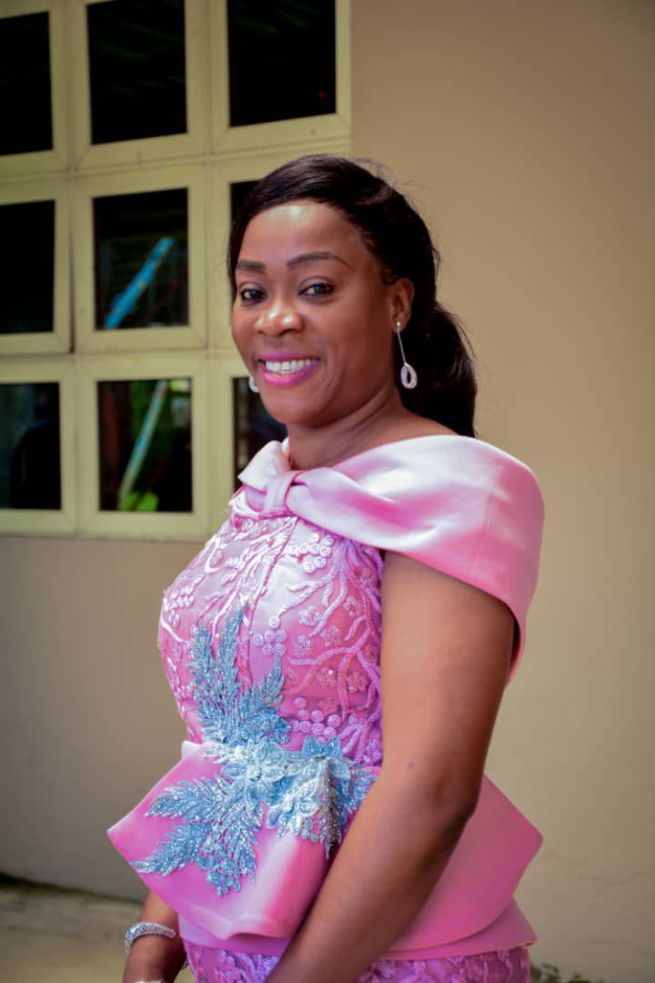
This month of April is Autism Month.
Today we celebrate Omon Olohigbe Omoike, a woman who has been at the center of care for many special children in Nigeria.
She is the founder of Salem Montessori School. A distinguished philanthropist virtuoso and adjunct special needs Educator with specialization on the intervention and advocacy for the children living with Autism spectrum disorder and other special needs children. She is very passionate about her work and this has directly led to the rehabilitation and reintegration of over one hundred indigent children and empowered scores of others in Edo State. She provides educational scholars for Autistic children and has won several awards in child care.

Being social and making friends isn’t always easy. Relationships have many subtleties. But people with autism spectrum disorder that she works with, struggle find so much joy in being with her. For them, communicating with others can be very difficult. Autism is called a “spectrum” disorder because it’s not the same for everyone. Generally, people with autism both have difficulties with social communication and engage in repetitive behaviours.
ASD can also affect learning and problem-solving abilities. But people with ASD range from being very gifted to having severe challenges. Some people with ASD need a great deal of support and more extensive services, and some have a milder range of difficulties and need less support.
Scientists don’t know the exact causes of ASD. They’re working hard to understand how different factors contribute. Genes, biology, and environment all can play a role in its development. Parents of children with ASD may notice their child doesn’t respond to their name, avoids eye contact, or interacts with others only to achieve a specific goal. Kids with autism usually don’t understand how to play or engage with other children.

